**CYBER SECURITY AND FORENSICS**

**PRACTICAL – VI B**

**NAME: NAGENDRA GUPTA ROLL NO: 020**

**DATE: 24/01/2025**

**AIM: DOS ATTACK IN WINDOWS USING KALI LINUX**

**STEP I: Reduce the security of the system.**

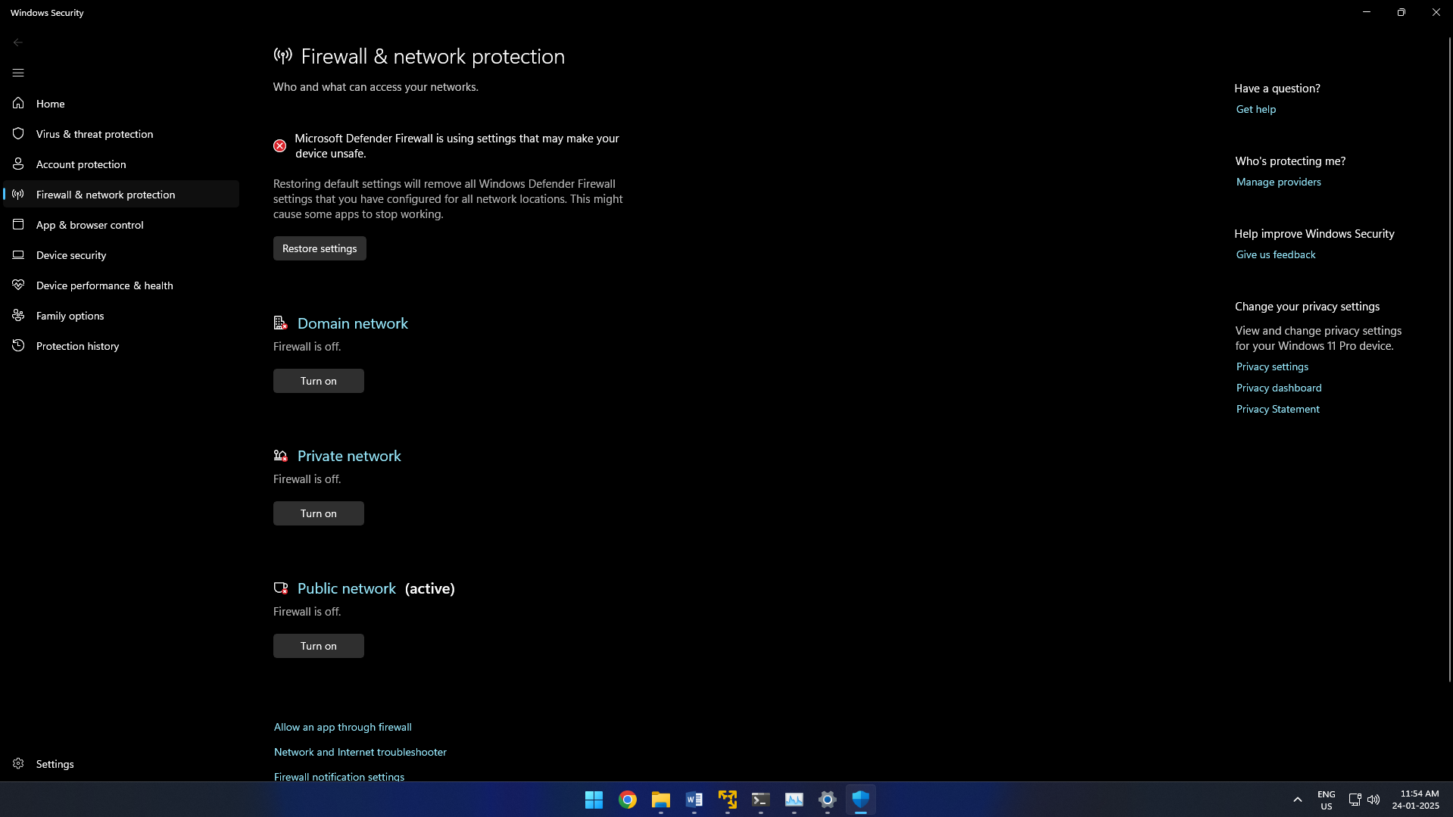

**STEP II : Get the IP address of your windows machine.**

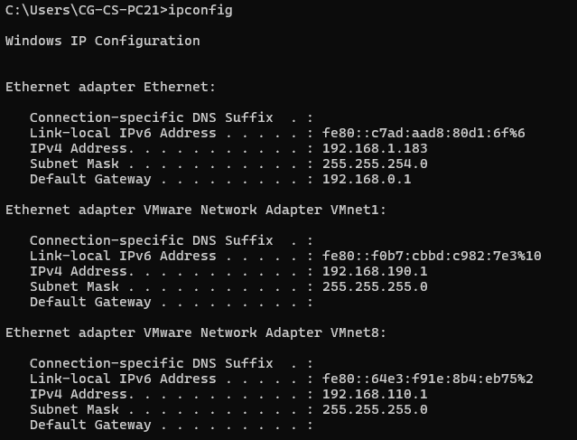

**STEP III: Check the performance in taskmanager**

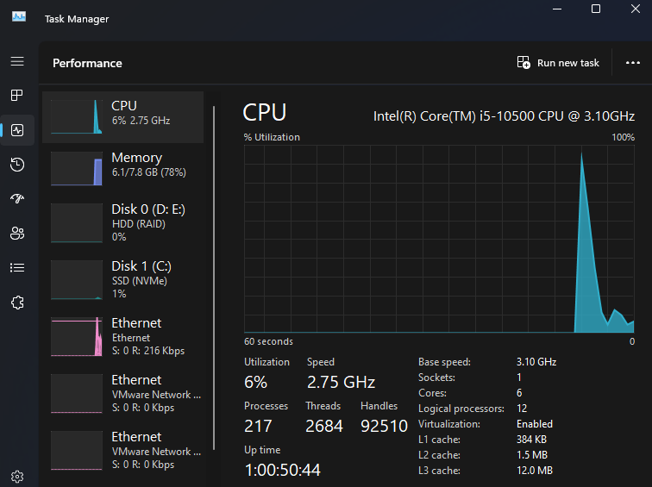

**STEP IV: Nmap the open ports in kali linux.**

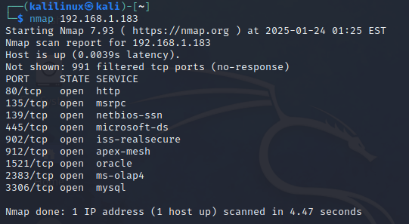

**STEP V: Attack the IP address on the open port the windows will be attacked.**

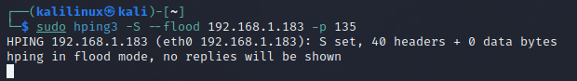

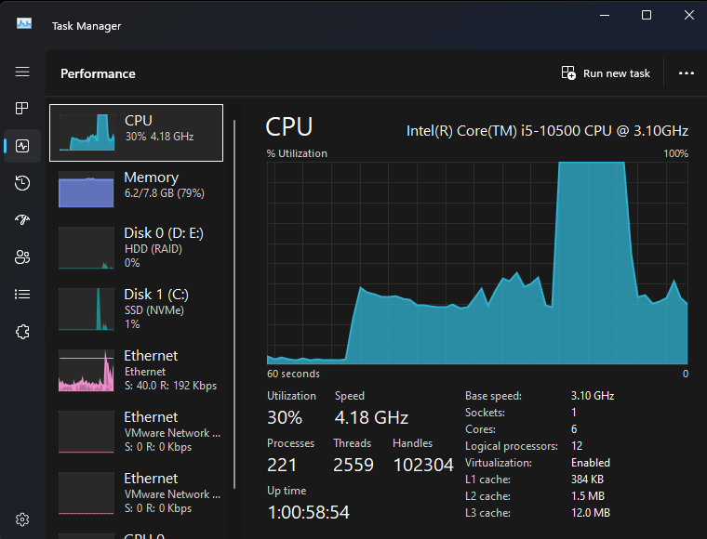

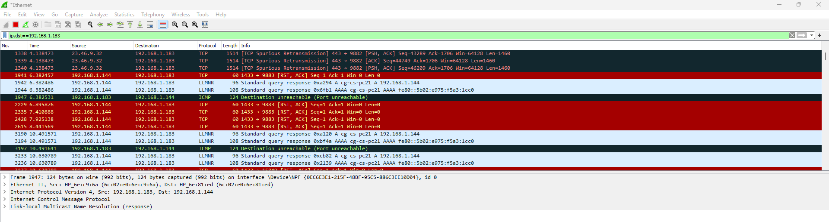

**STEP VI: Now attack with random Ip address.**

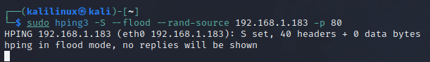

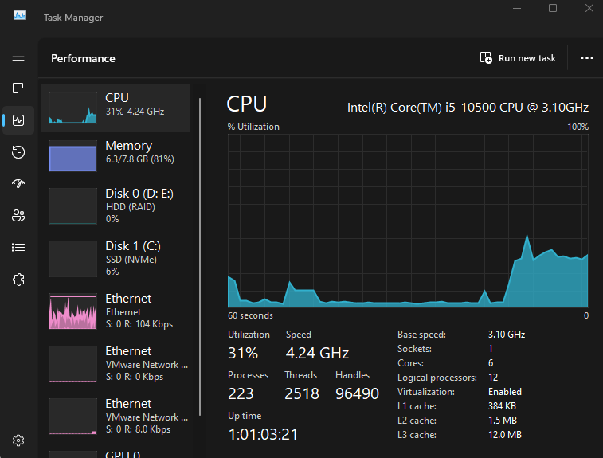

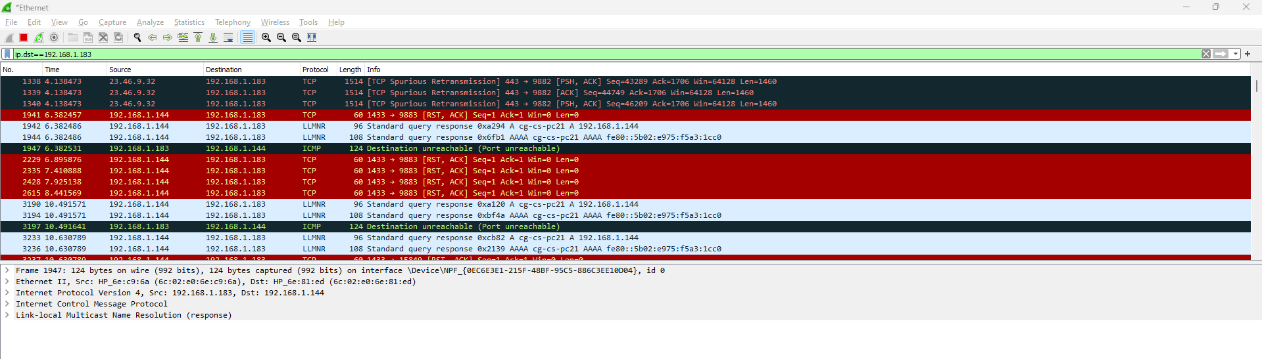

**STEP VII: Now attack with ICMP Packets.**

